# CS 340 README

## About the Project/Project Title

The CS 340 Project is a Python module designed to facilitate CRUD operations (create, read, update, delete) for interacting with a MongoDB database. It provides a convenient way for users to perform basic operations using Python code.

## Motivation

The motivation behind the CS 340 project is to simplify the process of database interaction for Python developers. By creating a Python moule that encapsulates CRUD functionality, developers can focus more on their application logic and less on database management tasks.

## Getting Started

To get started with the CS 340 project locally, follow these simple steps:

1. Enter Mongo and import the csv file.
2. create a simple index to parse data stored in the document.
3. authenticate the user by creating both an admin and an accuser account to access the database.
4. create the CRUD portions of python.
5. create a test file to test your animal file

## Installation

Linux system

* Python – this is accessible through the Linux terminal, run .py and .ipymb files.
* Mongo DB – to access the database.
* PyMongo Library – install using ‘pip install pymongo’.

## Usage

### Code Example

### The python script allows a user to create, read, update, and delete animals in a shelter.

### Tests

To run the tests,

I created a test file to ensure everything comes true. It reads the result, if the result is correct it prints ‘true’.

### Screenshots

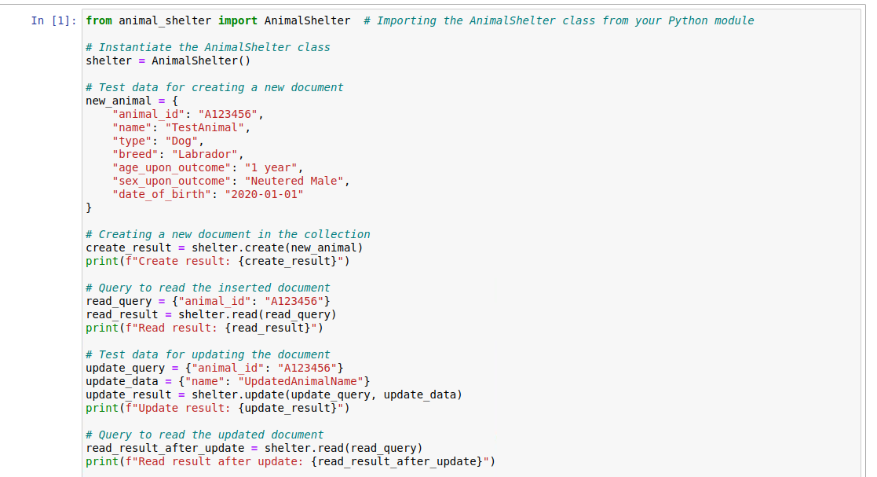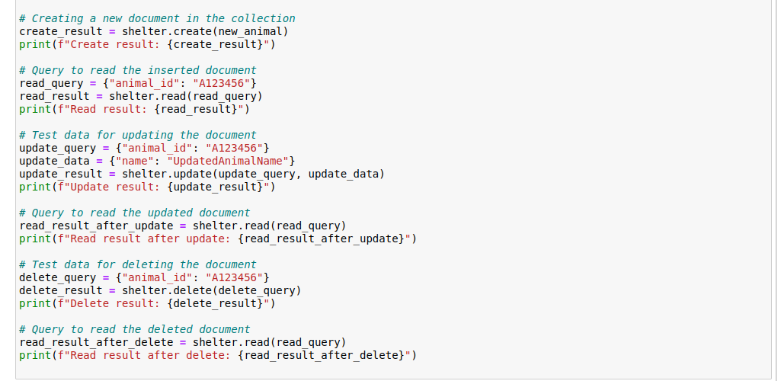

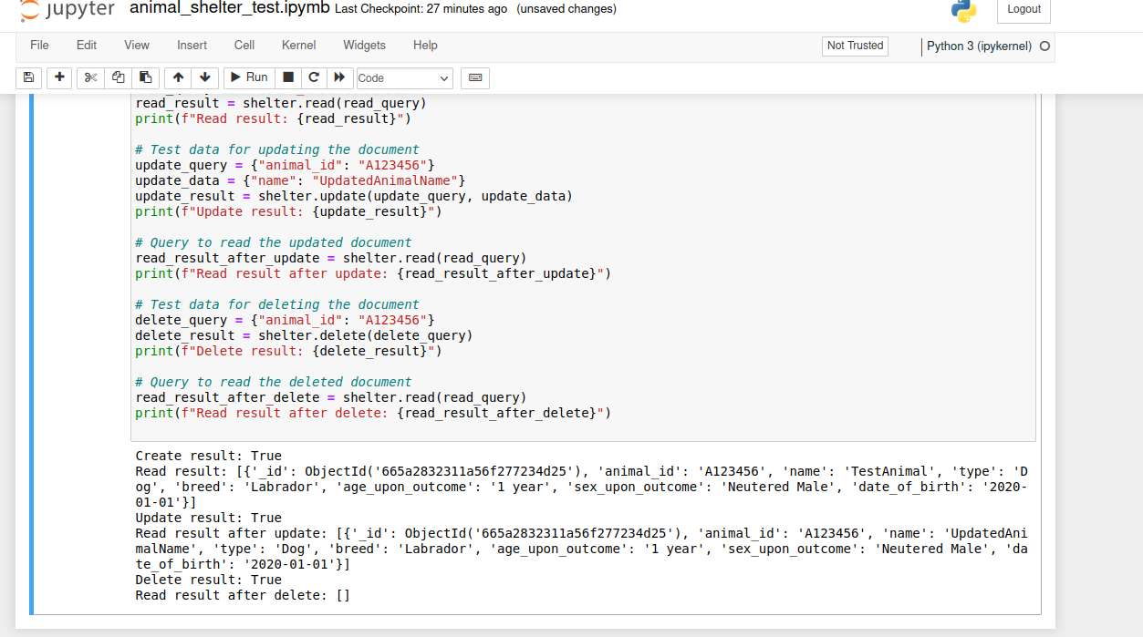

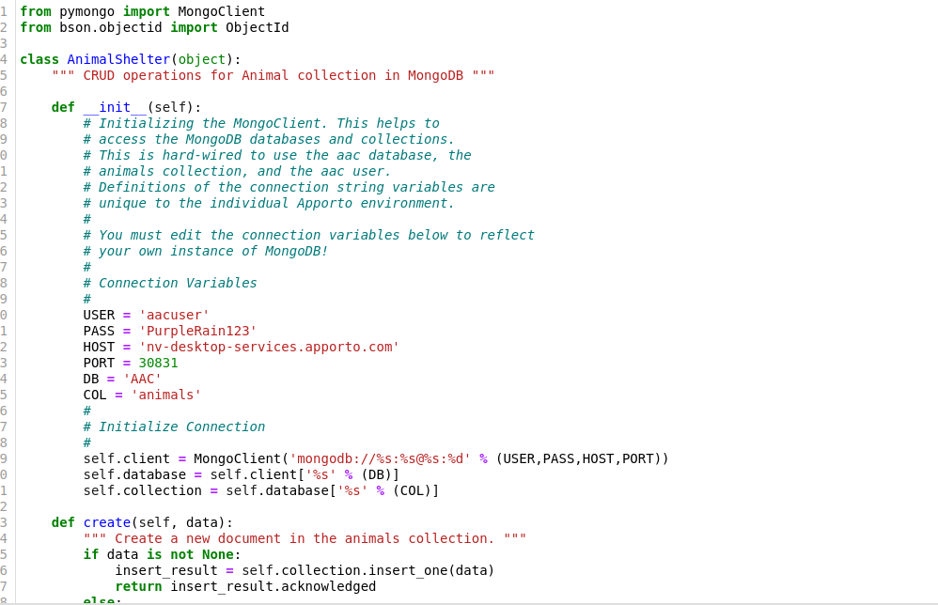

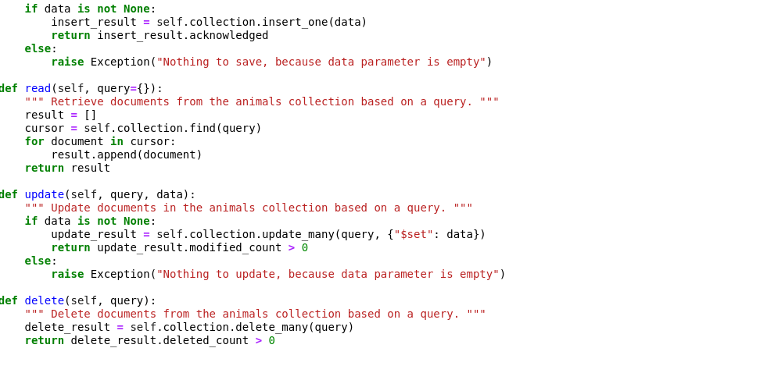

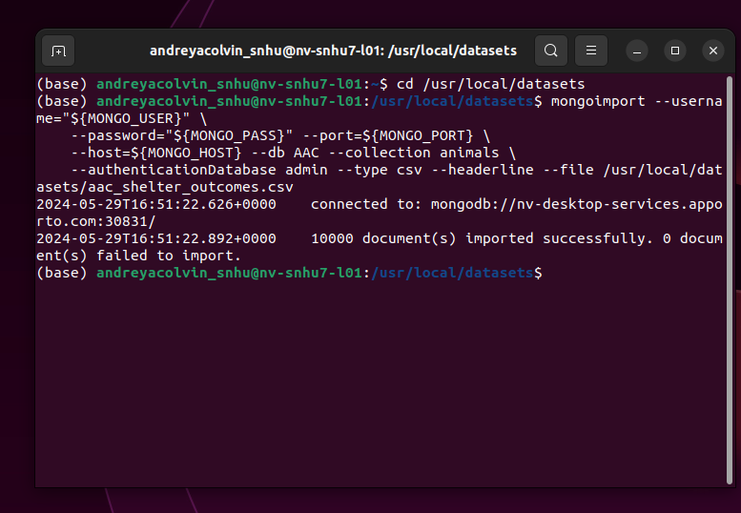

## Contact

Andreya Colvin